MIS5303 Securing Software
Lab 5 — Cryptography, Hashing & Data Protection
Assessment 1 — Supervised Practical Lab Submission
Field | Detail
Name | Ashraful Islam
Student ID | 240135
Lab number | Lab 5 (Week 6)
Date of completion | [ dd/mm/2026 ]
Subject | MIS5303 Securing Software
Lecturer | Dr Omid Haass
Note on scope: this lab adds protection rather than exploiting a flaw, so evidence is shown as before (baseline app.py, no crypto) vs after (app_fixed.py, bcrypt + Fernet + secure cookies). Both users (alice = baseline, bob = protected) sit in the same database for direct before/after comparison.

1. Where Sensitive Data Is Handled (Baseline)
ID | Data | Where | Baseline state | Risk
D1 | User password | register() / login() | Stored & compared in plaintext | DB leak exposes every password instantly
D2 | Note content | add_note() / index() | Stored in plaintext | DB leak or backup theft exposes personal/clinical notes
D3 | Session identity | Flask session cookie | No HttpOnly/SameSite flags | Cookie theft via XSS or cross-site misuse

Evidence — before (baseline app.py)
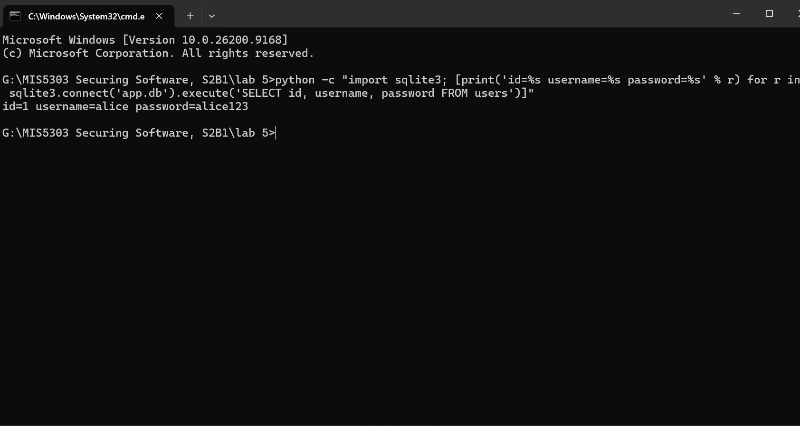
Figure 1: alice's password stored in plaintext in app.db.
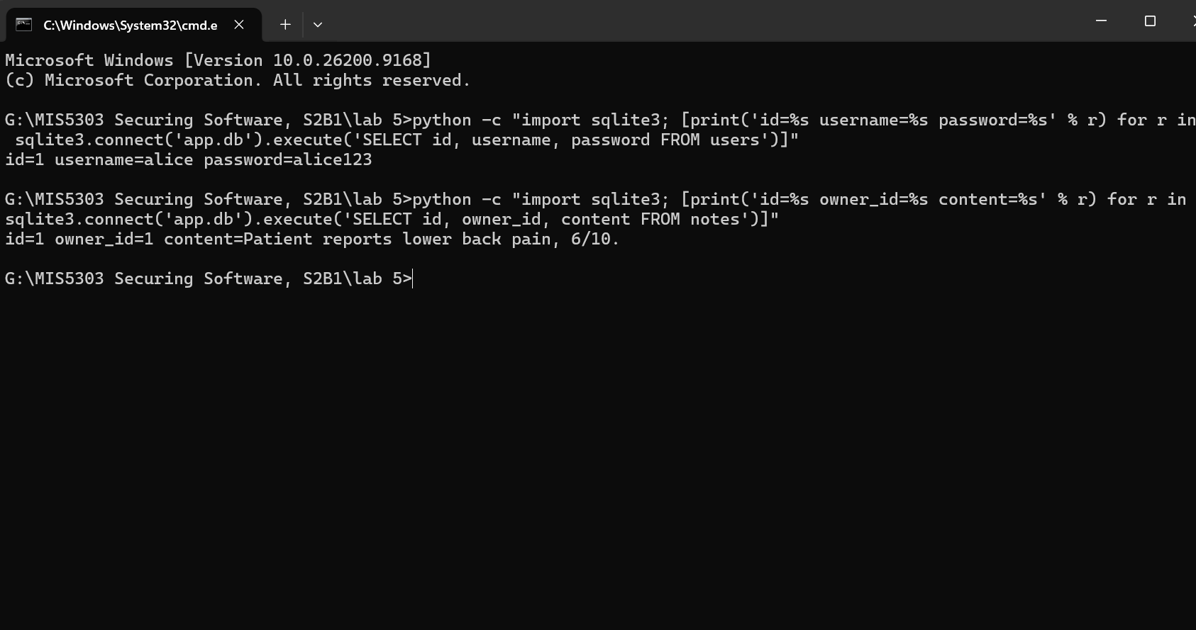
Figure 2: alice's note content stored in plaintext in app.db.

2. Remediation — Secure Code (Before / After)

2.1 Password hashing (bcrypt)
Before:
conn.execute("INSERT INTO users (username,password) VALUES (?,?)", (username, password))
After:
password = request.form["password"].encode("utf-8")
hashed = bcrypt.hashpw(password, bcrypt.gensalt(rounds=12))
c.execute("INSERT INTO users (username,password) VALUES (?,?)", (username, hashed))
# login: bcrypt.checkpw(password, row["password"].encode())
Why: bcrypt is a deliberately slow, adaptive hash with a built-in per-password salt, so identical passwords produce different hashes and offline brute-force is far harder than with a fast hash like MD5/SHA-256.

2.2 Note encryption (Fernet)
Before:
c.execute("INSERT INTO notes (owner_id, content) VALUES (?, ?)", (session["user_id"], content))
After:
encrypted_content = FERNET.encrypt(content.encode("utf-8"))
c.execute("INSERT INTO notes (owner_id, content) VALUES (?, ?)", (session["user_id"], encrypted_content))
# display: FERNET.decrypt(row["content"].encode()).decode("utf-8")
Why: Fernet provides authenticated symmetric encryption (AES-128 in CBC mode with an HMAC), so note content is unreadable at rest and any tampering with the ciphertext is detected on decryption.

2.3 Session cookie hardening
app.config.update(SESSION_COOKIE_HTTPONLY=True, SESSION_COOKIE_SAMESITE="Lax",
PERMANENT_SESSION_LIFETIME=timedelta(minutes=15))

Evidence — after (protected app_fixed.py)
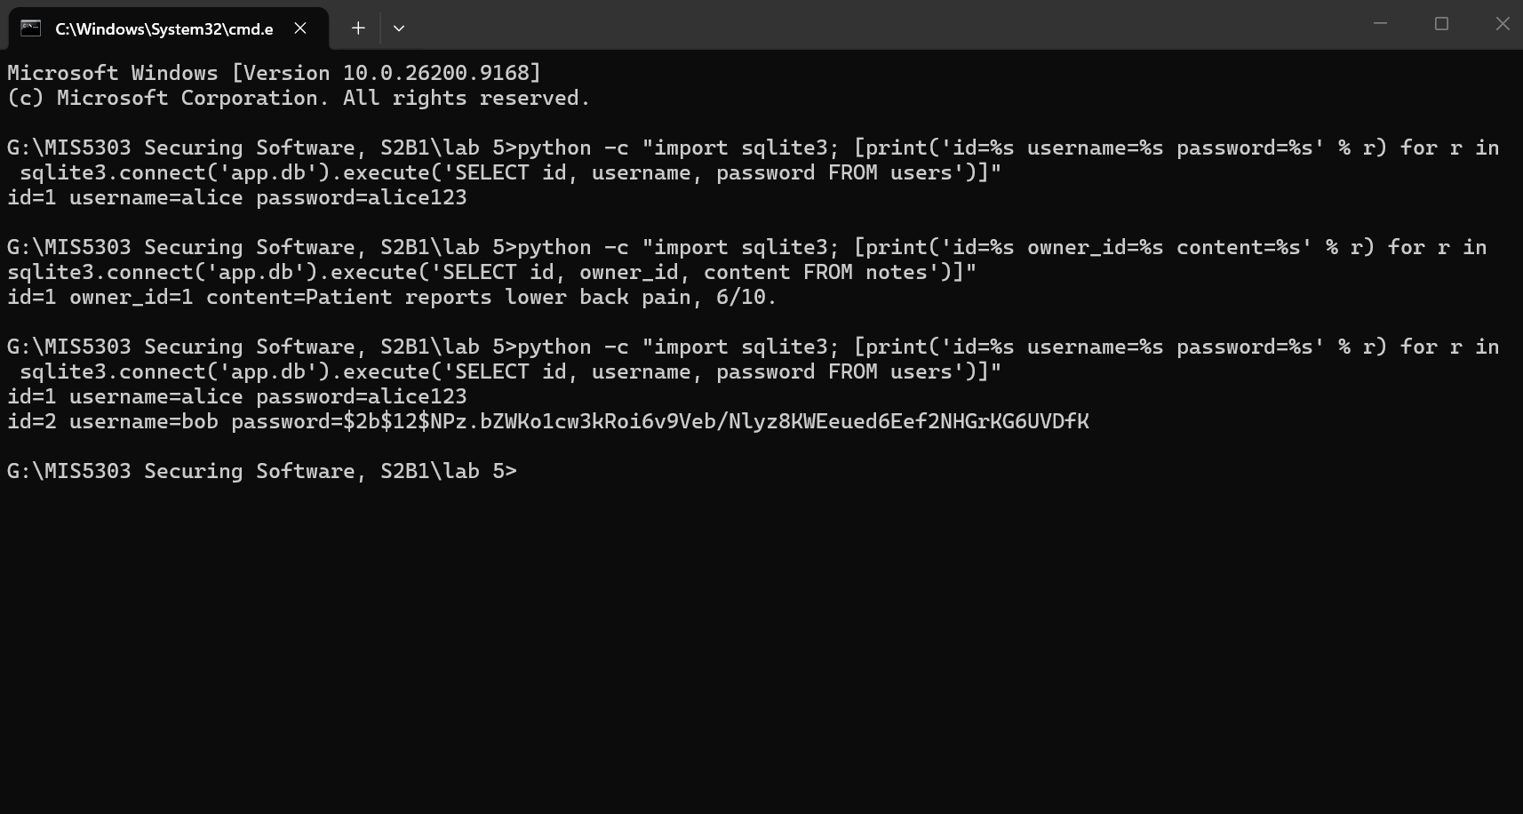
Figure 3: alice's old plaintext password next to bob's new bcrypt hash ($2b$12$...) in the same database.
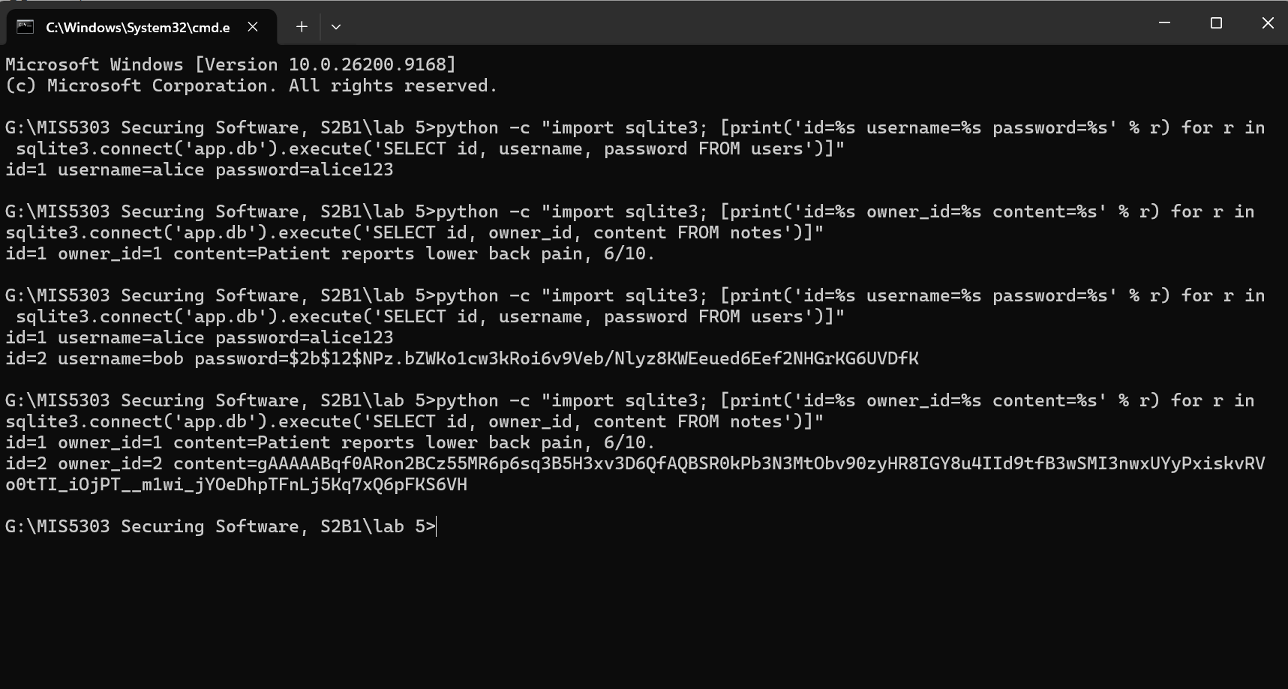
Figure 4: alice's old plaintext note next to bob's new Fernet ciphertext (gAAAAA...) in the same database.
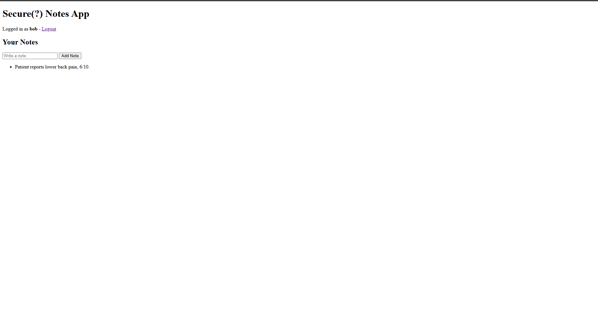
Figure 5: the app decrypts on display, so bob sees his note as normal readable text even though the database only holds ciphertext.
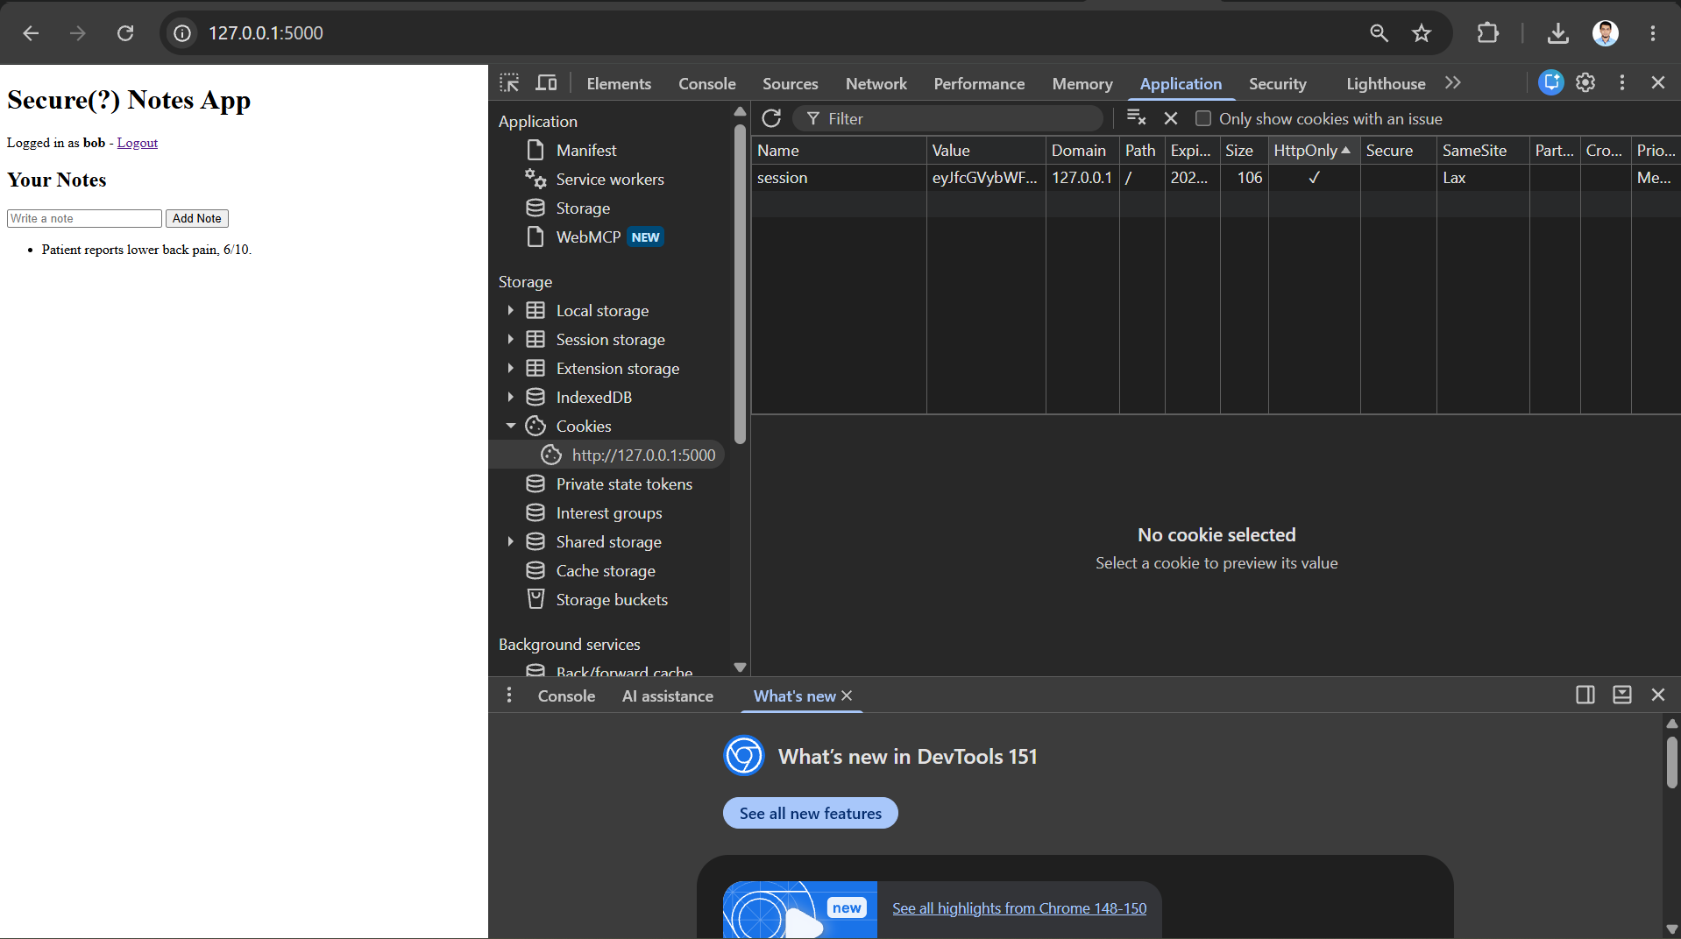
Figure 6: the session cookie now shows HttpOnly enabled and SameSite set to Lax.

3. Architect's Perspective — Crypto Design and Justification
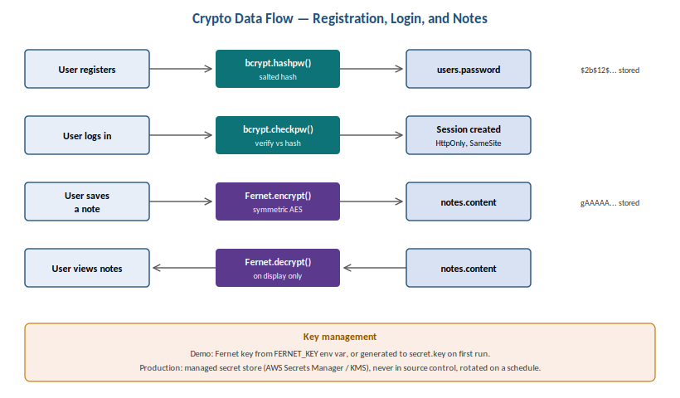
Figure 7: crypto data-flow diagram showing where hashing, encryption, and decryption occur.
Data / Field | Protection | Library | Justification
Passwords | Hash + salt (bcrypt, cost 12) | bcrypt | Protects against offline attacks if the DB is stolen; salt defeats rainbow tables; adaptive cost keeps pace with faster hardware
Notes | Symmetric encryption (Fernet / AES) | cryptography (Fernet) | Prevents data leakage if the DB or a backup is stolen; authenticated encryption also detects tampering
Sessions | Secure cookie flags + timeout | Flask config | HttpOnly stops JS/XSS reading the cookie; SameSite limits CSRF; a 15-min idle timeout limits a stolen session's window

Key management (Part 3 requirement)
What I encrypted, and why: note content is the field most likely to contain personal or clinical detail typed freely by the user, so it is the highest-value target if the database is ever exfiltrated. Passwords use hashing rather than encryption because the app never needs to recover the original password - only verify it - so a one-way, salted hash is the stronger and simpler control.
How I would handle key management in production: for this lab the Fernet key is loaded from a FERNET_KEY environment variable, falling back to a locally generated secret.key file with a console warning - a demo convenience only. In production the key must instead be generated and held in a managed secret store such as AWS Secrets Manager or AWS KMS, never committed to source control or written beside the application code, retrieved by the app at runtime with least-privilege IAM permissions, and rotated on a schedule with existing data re-encrypted under the new key. Access to the key itself should be logged and alertable, since compromising the key is equivalent to compromising every note it protects.

Threats addressed, and what remains
This design addresses credential theft from a stolen database (via hashing), bulk data exposure from a stolen database or backup (via encryption), and basic session/cookie theft (via secure flags). It does not yet address: encryption of data in transit beyond TLS being enabled at the infrastructure level, protection of the key itself if the server hosting the app is fully compromised while running (the key is in memory), or field-level access logging of who decrypted which note. These are reasonable next steps once the current controls are in place.

4. Individual Reflection
Write this yourself, in your own voice (150-250 words), like your earlier lab reflections. The lab sheet asks: what was hardest about adding crypto to a real app, and why do many apps still have crypto mistakes in production? For HD, also mention: how you verified the fix by re-checking the database (the plaintext-vs-hash and plaintext-vs-ciphertext contrast), and one limitation of your approach (e.g. the demo key-storage method vs a production secret store).
[ Your reflection here ]

5. Peer Review
Reviewer: Z N Zakaria (Student ID 240134). Peer feedback on this Lab 5 submission.
[ To the reviewer: please write your own comments under each heading. ]

Are the hashing/encryption changes robust?
[ reviewer writes here ]

Is the design justified and realistic?
[ reviewer writes here ]

Polishing / presentation
[ reviewer writes here ]
Reviewer signature: ____________________ Date: __________

6. Video Presentation Script (≈3 minutes)
Maps 1:1 to this report so the video and document stay coherent. Demonstrate live and narrate in your own words.

[0:00–0:20] Intro
- Name + student ID; state this is MIS5303 Lab 5 - cryptography, hashing and data protection.

[0:20–1:10] Baseline (before)
- Show app.db: alice's password and note both in plaintext (Figures 1-2). Say why that's dangerous if the DB is ever stolen.

[1:10–2:20] Protected app (after)
- Switch to app_fixed.py; register bob; log in successfully.
- Show the DB: bob's password is now a bcrypt hash next to alice's old plaintext (Figure 3).
- Add a note as bob; show the DB stores Fernet ciphertext (Figure 4), but the app page shows it decrypted and readable (Figure 5).
- Show the session cookie: HttpOnly and SameSite now set (Figure 6).

[2:20–3:00] Design and close
- Show the crypto data-flow diagram and the architect table; name one key-management point (env var / secret store, never hard-coded, rotated).
- Close with one honest sentence: what was hardest, and the key lesson about crypto mistakes in production.

7. Submission Checklist
- Cover details + date filled in
- Baseline data locations documented + BEFORE screenshots (Figures 1-2)
- Secure code shown for hashing, encryption, and session hardening
- AFTER screenshots proving each protection (Figures 3-6)
- Crypto data-flow diagram (Figure 7) + architect table
- Key-management justification written
- Reflection written in my own words — TO DO
- Peer review by Z N Zakaria (Part 5) — TO DO
- Video recorded, coherent with this document — TO DO
- GenAI cover sheet completed and signed — TO DO
- app.py (baseline) and app_fixed.py both included — DONE

